**SYSTEM SECURITY**

**LAB 4**

**P.R.N:** 20190802058

**Name:** Krushal Milan Shah

**Experiment:**

1. Write C/C++/Python/JAVA program to implement One Time Pad Encipher for string input. Use the following steps to implement.
2. Write C/C++/Python/JAVA program to implement One Time Pad Encipher for binary input.

**Code:**

**1:**

PlainText = input("Please enter the plain text: ")

Key = 'XMCKL'

Key_Ascii_array = [0 for i in range (len(PlainText))]

for i in range(len(Key)):

Key_Ascii_array[i] = ord(Key[i])

PlainText_Ascii_array = [ 0 for i in range (len(PlainText))]

for i in range(len(PlainText)):

PlainText_Ascii_array[i] = ord(PlainText[i])

#PlainText_Ascii_array[i] = bin(ord(PlainText)).replace("0b","")

PlainText_Ascii_array

Key_Ascii_array

#Encription

Cipher_Text_array= [0 for i in range (len(PlainText))]

for i in range(len(PlainText)):

Cipher_Text_array[i] = chr(PlainText_Ascii_array[i] ^ Key_Ascii_array[i])

Cipher_Text_array

Decript_Text_Array = [0 for i in range (len(PlainText))]

for i in range(len(PlainText)):

Decript_Text_Array[i] = chr(ord(Cipher_Text_array[i]) ^ Key_Ascii_array[i]);

Decript_Text_Array

**2:**

PlainText = str(input("Please enter plain text: "))

Key = str(input("Please enter the Key: "))

#Encription

Encript_Text = [0 for i in range(len(PlainText))]

for i in range(len(PlainText)):

Encript_Text[i] = int(PlainText[i]) ^ int(Key[i])

#Encript_Text = bin(int(PlainText^Key)).replace("0b","")

Encript_Text

#Decript

Decript_text = [0 for i in range(len(PlainText))]

for i in range(len(PlainText)):

Decript_text[i] = int(Encript_Text[i]) ^ int(Key[i])

Decript_text

**Results:**

**1**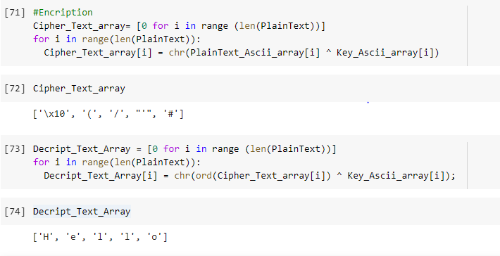

**2**

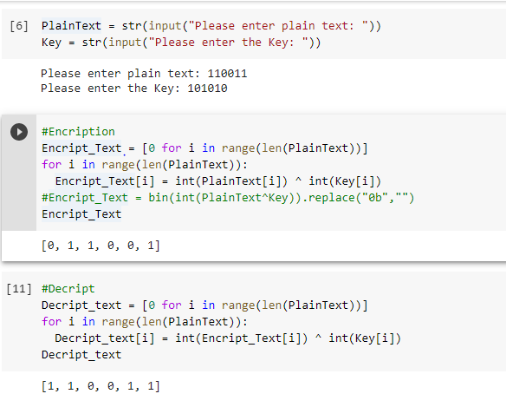

**Conclusion:**

Successfully implemented One Time Pad.